W03 Learning Activities: Code Comments
Overview
Comments written in code by developers provide a way to explain the purpose and function of that code. Since the code will need to be maintained and will change, comments can serve as reminders, to-do lists, code snippets, and notes for potential improvements during development. Comments are not processed or displayed to the user in the rendered document in HTML or CSS. Comments can be placed in any available white space.
Prepare
HTML comments are not rendered in the browser. Here is an HTML comment syntax example:
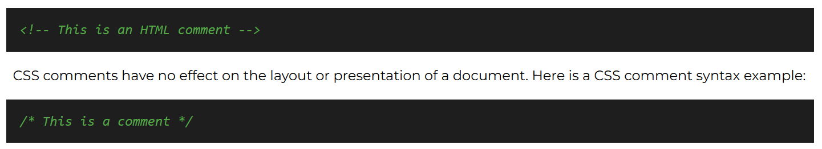
You can use comments in your learning activities and assignments to remind yourself of things you want to reference or document for future use. While these comments are for your personal use, keep in mind that organizations may have specific commenting requirements because many developers might work on a project over its lifetime.
The concept of comments is also used in your git commits, which are especially useful for tracking revision history and providing context to your commits for your development team.
Creating comments in VS Code
You can create comments by typing <!-- and --> directly into your HTML files, or /* and */ directly into your CSS files. In addition, VS Code and many other editors have a keyboard shortcut for adding comments: hold the Ctrl key (Cmd on macOS) and press the forward slash / key. Press it again to uncomment a line.
This keyboard shortcut is very useful for commenting out a section of code that already exists. Simply highlight the code you want to comment out and press Ctrl+/ (or Cmd+/ on macOS).
Activity Instructions
- Open any HTML or CSS document in VS Code.
- Use Ctrl+/ (macOS: Cmd+/) to comment out the line of code where your cursor is currently located, or multiple lines of code that you have selected.
- Pressing Ctrl+/ (or Cmd+/) again will toggle the commented lines back to active code.

